GLOBAL AIR TRANSPORTATION NETWORK

1. INTRODUCTION

The worldwide air transportation network is a small-world network in which (i) the number of nonstop connections from a given city and (ii) the number of shortest paths going through a given city have distributions that are scale-free

* 1. OVERVIEW

The air transport system generally includes airports, ATC (air traffic control) system, and airlines. The airports represent the ground part of the system's infrastructure handling the aircraft operated by different airlines transporting passengers and freight/cargo shipments

* 1. PURPOSE

Air transport is one of the fastest modes of public transport which connects international boundaries. Air transport allows people from different countries to cross international boundaries and travel other countries for personal, business, medical, and tourism purposes.

1. PROBLEM STATEMENT & DESIGN THINKING

Some key factors that influence the aviation industry globally include globalization, rising incomes, the expansion of low-cost carriers, and technological improvements. Each of these factors uniquely shapes the aviation industry and drives demand for air travel. Design thinking is made up of five steps: empathize, define, ideate, prototype and test. A critical element to digital Ttransformation is creating an excellent experience for the customers.

* 1. EMPATHY MAP

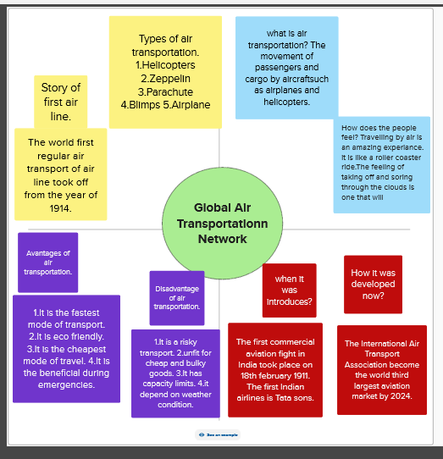

* 1. BRAINSTORMING MAP

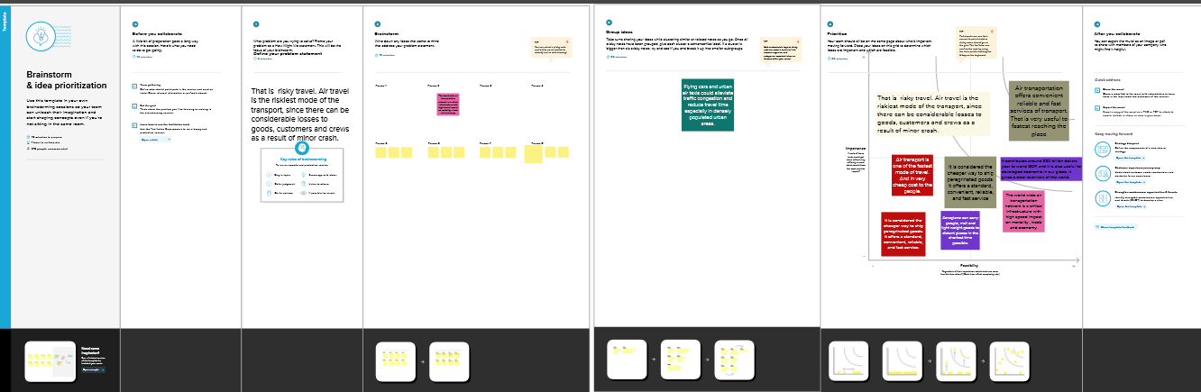

1. RESULT
   1. AIRPORTS AT HIGHER ALTITUDE WITHIN A COUNTRY

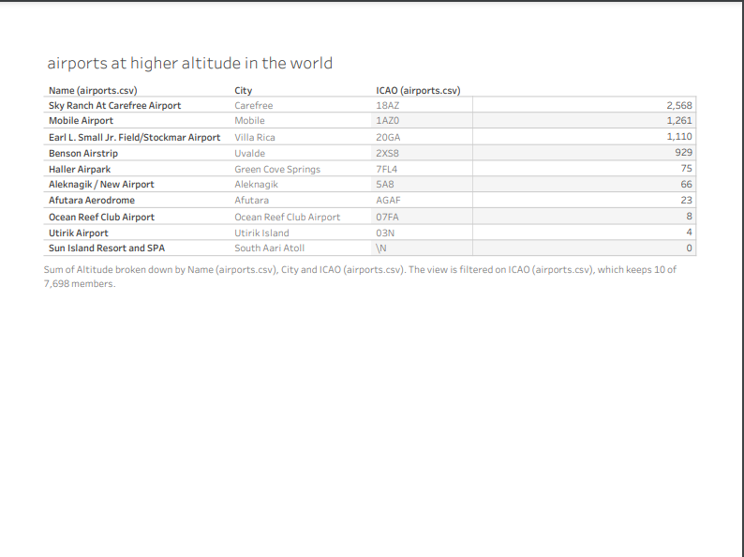

* 1. NUMBER OF AIRPORTS

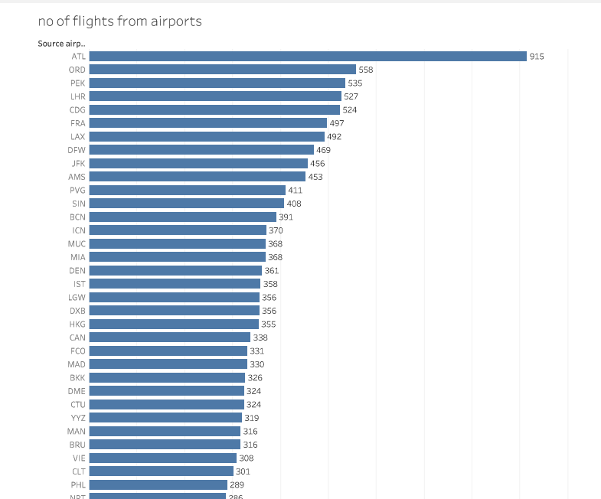

* 1. WORLD MAP SHOWING DETAILS OF ALL AIRPORTS WITHIN A COUNTRY

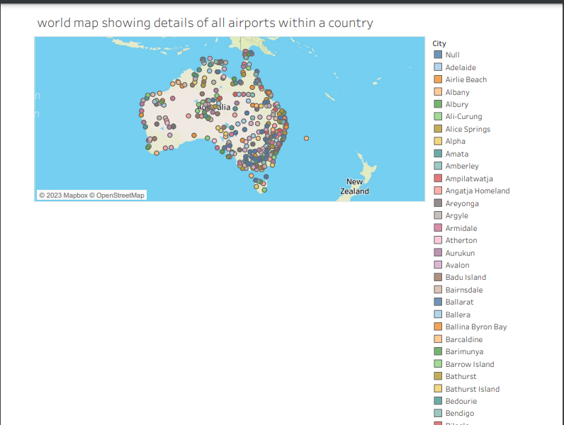

* 1. AIRLINES WITHIN A COUNTRY

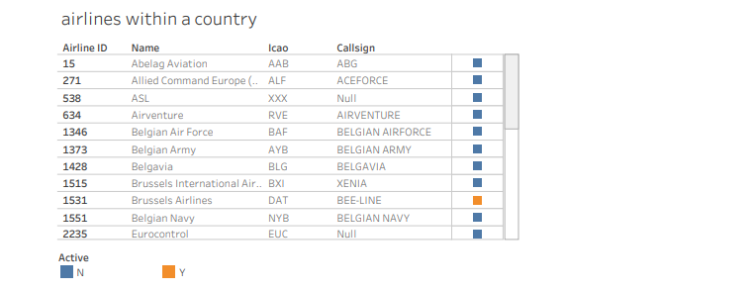

* 1. NUMBER OF FLIGHTS FROM AIRPORTS



3.6 AIRPORTS AT HIGHER ALTITUDE IN THE WORLD



* 1. DASHBOARD

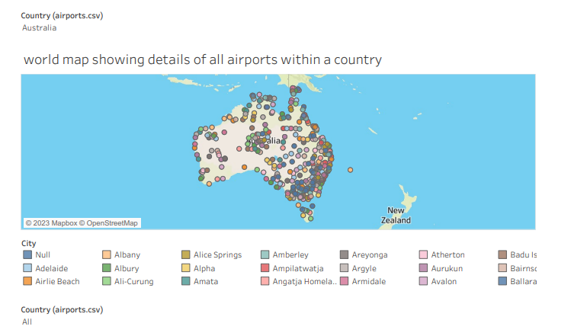

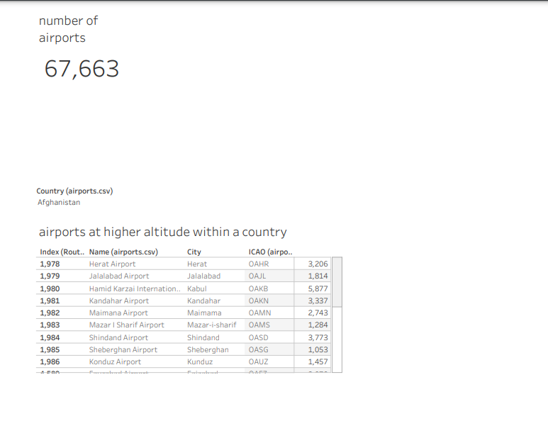

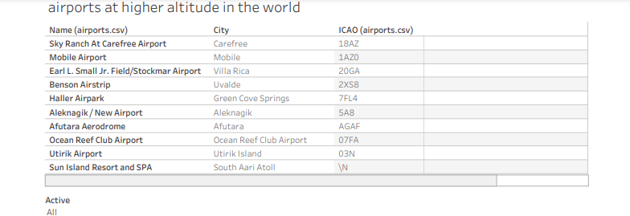

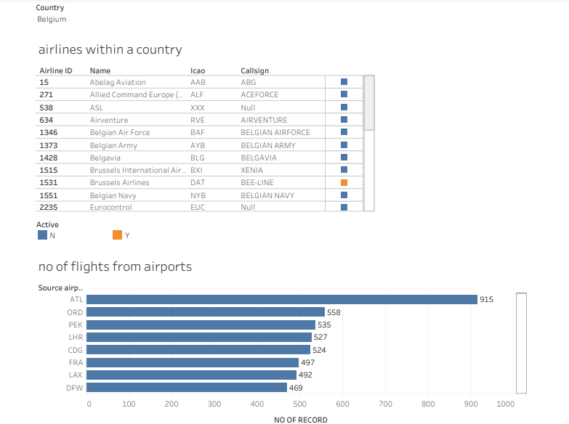

3.8 STORY

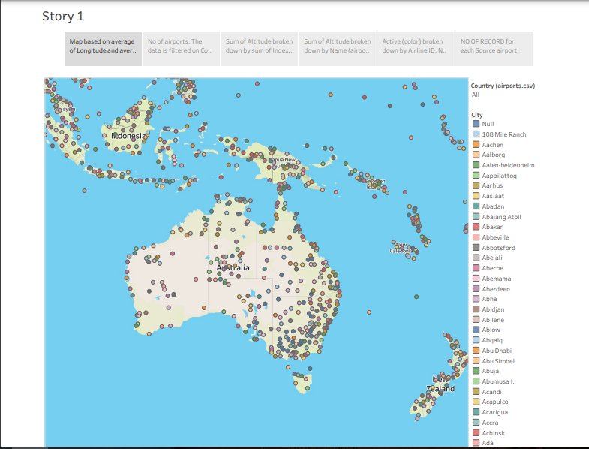



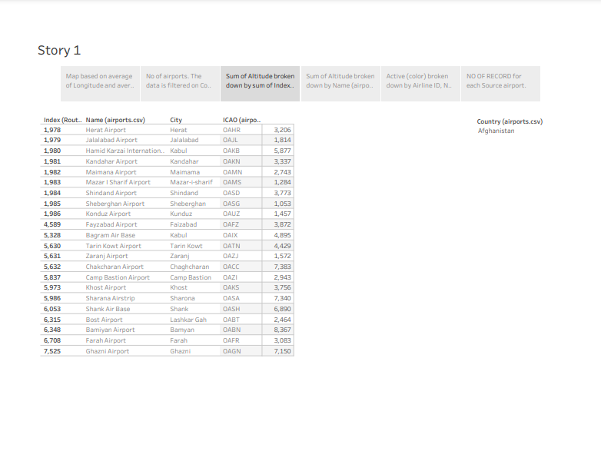

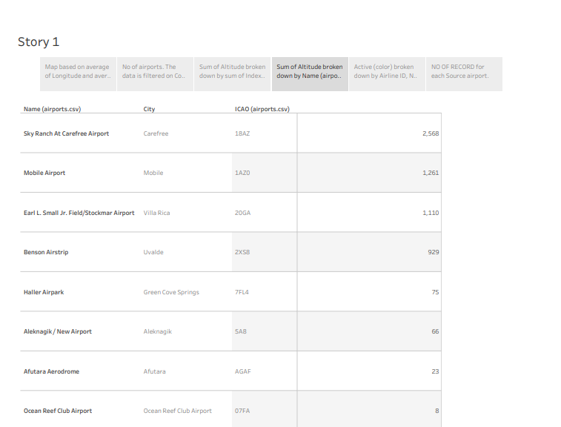

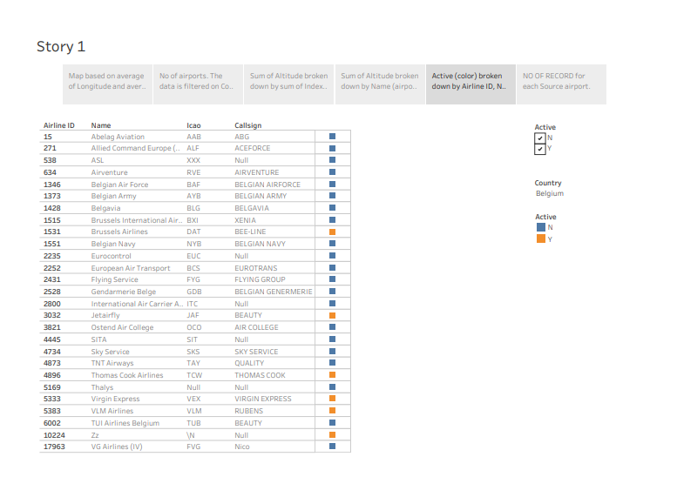

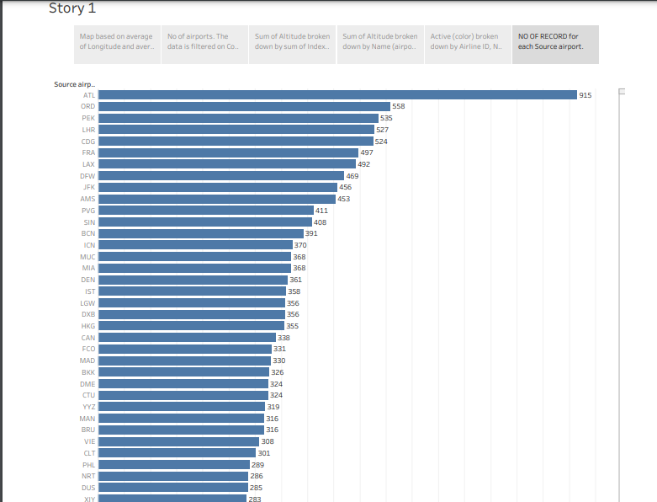

1. advantages and disadvantages

advantages

To understand the **importance of air transport**, its special characteristics must be taken into account. This overlooks a number of advantages that are very attractive and perfectly adapted to the specific needs of each company.

**Fast delivery times**

Undoubtedly, one of the most advantageous features offered by air transport is its **speedy delivery times**.

**There is no faster transport service than air transport**. In addition, the frequency of flights makes delivery times very frequent and fast.

**No Physical Limits**

Air transport is the only means of transportation that **does not support physical limits**. Road transport, for example, must undergo different physical constraints that slow down delivery times.It is one of the means of transportation that offers practically no interruption in its services, which is very attractive for companies.

**Very reliable transportation**

One of the great advantages of air transport for both passengers and goods is its great **reliability**.Delays in delivery dates or loss of goods are options that can be very difficult to achieve with this means of transport.

**Long Distances**

No other means of transport in the logistics sector can **cover** such **long distances** as air transport. This is a **great advantage for international trade**, being able to cover long distances, impossible for road or sea transport.

disadvantages

Although the advantages of air transport are very attractive and define a totally unbeatable type of service, it is also possible to define a series of disadvantages that should be analyzed to determine whether air transport is appropriate or whether it is preferable to consider other types of transport, such as **sea transport**.

### Higher Cost

There is no doubt that air transport is the least economical means of transportation compared to other types of transport.

The cost of infrastructure, fuel… makes air transport economically superior to other alternatives.

It is important to know how to analyze and calculate the economic and logistical performance to know if it is the ideal option to be used.

### Less storage capacity

Storage capacity is lower than land and sea transport. This is a clear disadvantage, air transport is ideal for medium or low loads, but is not so attractive for large volumes of goods.

One of the significant drawbacks of air transport is its higher cost compared to other modes, such as sea or land transport. Air freight charges are generally higher due to factors like fuel costs, infrastructure investments, and handling fees.

Emissions from aviation are a significant contributor to climate change. Airplanes burn fossil fuel which not only releases CO2 emissions but also has strong warming non-CO2 effects due to nitrogen oxides (NOx), vapour trails and cloud formation triggered by the altitude at which aircraft operate

1. application

Modeling air transport networks aims airline companies to organize their routes in a cost-efficient way and therefore maximize their profits. Air transport network models are also the tool to investigate system robustness. They help to determine weaknesses of the system in case of various kinds of disruptions.[[4]](https://en.wikipedia.org/wiki/Air_Transport_Network#cite_note-Lordan-4)[[6]](https://en.wikipedia.org/wiki/Air_Transport_Network#cite_note-Hu-6) Once weaknesses are determined, a substitute node which can support all or part of the traffic load can be identified through the alternative strength for the pair.[[7]](https://en.wikipedia.org/wiki/Air_Transport_Network#cite_note-7)

An alternative application is modeling human disease networks. Air transport network is used by millions of people every day, therefore it plays key role in the spread of some infections, such as influenza or [SARS](https://en.wikipedia.org/wiki/SARS). In this sense air transport network is a transmitter similar to [sexual networks](https://en.wikipedia.org/wiki/Sexual_network), which is liable for the spread of AIDS and other sexually transmitted diseases.

## Abstract

We analyze the global structure of the worldwide air transportation network, a critical infrastructure with an enormous impact on local, national, and international economies. We find that the worldwide air transportation network is a scale-free small-world network. In contrast to the prediction of scale-free network models, however, we find that the most connected cities are not necessarily the most central, resulting in anomalous values of the centrality. We demonstrate that these anomalies arise because of the multicommunity structure of the network. We identify the communities in the air transportation network and show that the community structure cannot be explained solely based on geographical constraints and that geopolitical considerations have to be taken into account. We identify each city's global role based on its pattern of intercommunity and intracommunity connections, which enables us to obtain scale-specific representations of the network.

The air transportation system is also responsible, indirectly, for the propagation of diseases such as influenza and, recently, severe acute respiratory syndrome (SARS). The air transportation network thus plays for certain diseases a role that is analogous to that of the web of human sexual contacts ([5](https://www.pnas.org/doi/10.1073/pnas.0407994102#core-ref5)) for the propagation of AIDS and other sexually transmitted infections ([6](https://www.pnas.org/doi/10.1073/pnas.0407994102#core-ref6), [7](https://www.pnas.org/doi/10.1073/pnas.0407994102#core-ref7)).

The worldwide air transportation network is responsible for the mobility of millions of people every day. Almost 700 million passengers fly each year, maintaining the air transportation system ever so close to the brink of failure. For example, U.S. and foreign airlines schedule ≈2,700 daily flights in and out of O'Hare International Airport (Chicago) alone, >10% of the total commercial flights in the continental U.S. and more than the airport could handle even during a perfect “blue-sky” day. Low clouds, for example, can lower landing rates at O'Hare from 100 per hour to just 72 per hour, resulting in delays and flight cancellations across the country. The failures and inefficiencies of the air transportation system have large economic costs; flight delays cost European countries 150 billion to 200 billion Euro in 1999 alone ([8](https://www.pnas.org/doi/10.1073/pnas.0407994102#core-ref8)).

These facts prompt several questions. What has led the system to this point? Why can't we design a better system? To answer these questions, it is crucial to characterize the structure of the worldwide air transportation network and the mechanisms responsible for its evolution. The solution to this problem is, however, far from simple. The structure of the air transportation network is mostly determined by the concurrent actions of airline companies, both private and national, that try, in principle, to maximize their immediate profit. However, the structure of the network is also the outcome of numerous historical “accidents” arising from geographical, political, and economic factors.

Much research has been conducted on the definition of models and algorithms that enable one to solve problems of optimal network design ([9](https://www.pnas.org/doi/10.1073/pnas.0407994102#core-ref9), [10](https://www.pnas.org/doi/10.1073/pnas.0407994102#core-ref10)). However, a worldwide, “system” level analysis of the structure of the air transportation network is still lacking. However, just as one cannot fully understand the complex dynamics of ecosystems by looking at simple food chains ([11](https://www.pnas.org/doi/10.1073/pnas.0407994102#core-ref11)) or the complex behavior in cells by studying isolated biochemical pathways ([12](https://www.pnas.org/doi/10.1073/pnas.0407994102#core-ref12), [13](https://www.pnas.org/doi/10.1073/pnas.0407994102#core-ref13)), one cannot fully understand the dynamics of the air transportation system without a “holistic” perspective. Modern “network analysis” ([14](https://www.pnas.org/doi/10.1073/pnas.0407994102#core-ref14)–[18](https://www.pnas.org/doi/10.1073/pnas.0407994102#core-ref18)) provides an ideal framework within which to pursue such a study.

We analyze here the worldwide air transportation network. We build a network of 3,883 locales, villages, towns, and cities with at least one airport and establish links between pairs of locales that are connected by nonstop passenger flights. We find that the worldwide air transportation network is a small-world network ([19](https://www.pnas.org/doi/10.1073/pnas.0407994102#core-ref19)) for which (*i*) the number of nonstop connections from a given city and (*ii*) the number of shortest paths going through a given city have distributions that are scale-free. In contrast to the prediction of scale-free network models, we find that the most-connected cities are not necessarily the most “central,” that is, the cities through which most shortest paths go. We show that this surprising result can be explained by the existence of several distinct “communities” within the air transportation network. We identify these communities by using algorithms recently developed for the study of complex networks and show that the structure of the communities cannot be explained solely based on geographical constraints and that geopolitical considerations also must be taken into account. The existence of communities leads us to the definition of each city's global role, based on its pattern of intercommunity and intracommunity connections.

## Data

We focused our analysis on a network of cities, not of airports; for example, Newark Liberty International Airport, John F. Kennedy International Airport, and LaGuardia Airport are all assigned to New York City. We further restricted our analysis to passenger flights operating in the time period November 1, 2000, to November 7, 2000. Even though these data are >4 years old, the resulting worldwide airport network is virtually indistinguishable from the network one would obtain if using data collected today. The reason is that air traffic patterns are strongly correlated with (*i*) socioeconomic factors, such as population density and economic development; and (*ii*) geopolitical factors, such as the distribution of the continents over the surface of the Earth and the locations of borders between states ([21](https://www.pnas.org/doi/10.1073/pnas.0407994102#core-ref21)). Clearly, the time scales associated to changes in these factors are much longer than the lag in the data we analyzed here.

During the period considered, there were 531,574 unique nonstop passenger flights, or flight segments, operating between 3,883 distinct cities. We identified 27,051 distinct city pairs having nonstop connections. The fact that the database is highly redundant, that is, that most connections between pairs of cities are represented by more than one flight, adds reliability to our analysis. Specifically, the fact that unscheduled flights are not considered does not mean, in general, that the corresponding link between a certain pair of cities is missing in the network, because analogous scheduled flights may still operate between them. Similarly, even if some airlines have canceled their flights between a pair of cities since November 2000, it is highly unlikely that all of them have.

We created the corresponding adjacency matrix for this network, which turns out to be almost symmetrical. The very minor asymmetry stems from the fact that a small number of flights follow a “circular” pattern, i.e., a flight might go from A to B to C and then back to A. To simplify the analysis, we symmetrized the adjacency matrix.

## Large-Scale Structure of the Air Transportation Network

A ubiquitous characteristic of complex networks is the so-called “small-world” property ([22](https://www.pnas.org/doi/10.1073/pnas.0407994102#core-ref22)). In a small-world network, pairs of nodes are connected by short paths as one expects for a random graph ([23](https://www.pnas.org/doi/10.1073/pnas.0407994102#core-ref23)). Crucially, nodes in small-world networks also have a high degree of cliquishness, as one finds in low-dimensional lattices but not in random graphs.

In the air transportation network, the average shortest path length *d* is the average minimum number of flights that one needs to take to get from any city to any other city in the world. We found that for the 719 cities in the Asia and Middle East network, *d* = 3.5 and that the average shortest path length between the 3,663 cities in the giant component of the worldwide network is only approximately one step greater, *d* = 4.4. Actually, most pairs of cities (56%) are connected by four steps or less. More generally, we found that *d* grows logarithmically with the number *S* of cities in the network, *d* ≈ log *S*. This behavior is consistent with both random graphs and small-world networks but not with low-dimensional networks, for which *d* grows more rapidly with *S*.

Still, some pairs of cities are considerably further away from each other than the average. The farthest cities in the network are Mount Pleasant in the Falkland Islands and Wasu, Papua New Guinea: To get from one city to the other, one needs to take 15 different flights. From Mount Pleasant, one can fly to Punta Arenas, Chile, and from there fly to some hubs in Latin America. At the other end of the path, from Wasu one needs to fly to Port Moresby (Papua New Guinea), which requires a unique sequence of eight flights. In the center of the path, between Punta Arenas and Port Moresby, six different flights are needed. In contrast to what happens the ends of the path, in the central region of the path there are hundreds of different flight combinations, all of them connecting Punta Arenas and Port Moresby in six steps.

The clustering coefficient *C*, which quantifies the local cliquishness of a network, is defined as the probability that two cities that are directly connected to a third city also are directly connected to each other. We find that *C* is typically larger for the air transportation network than for a random graph and that it increases with size. These results are consistent with the expectations for a small-world network but not with those for a random graph. For the worldwide network, we find that *C* = 0.62, whereas its randomization yields *C* = 0.049. Therefore, we conclude that the air transportation network is, as expected, a small-world network ([19](https://www.pnas.org/doi/10.1073/pnas.0407994102#core-ref19)).

Another fundamental aspect in which real-world networks often deviate from the random graphs typically considered in mathematical analysis ([23](https://www.pnas.org/doi/10.1073/pnas.0407994102#core-ref23)) is the degree distribution, that is, the distribution of the number of links of the nodes ([15](https://www.pnas.org/doi/10.1073/pnas.0407994102#core-ref15), [19](https://www.pnas.org/doi/10.1073/pnas.0407994102#core-ref19), [24](https://www.pnas.org/doi/10.1073/pnas.0407994102#core-ref24)). In binomial random graphs, all nodes have similar degrees, whereas many real-world networks have some nodes that are significantly more connected than others. Specifically, many complex networks, termed “scale-free,” have degree distributions that decay as a power law.

**Community Structure.** To identify communities in the air transportation network, we used the definition of modularity introduced in refs. [32](https://www.pnas.org/doi/10.1073/pnas.0407994102#core-ref32) and [33](https://www.pnas.org/doi/10.1073/pnas.0407994102#core-ref33). The modularity of a given partition of the nodes into groups is maximum when nodes that are densely connected among them are grouped together and separated from the other nodes in the network. To find the partition that maximizes the modularity, we used simulated annealing ([34](https://www.pnas.org/doi/10.1073/pnas.0407994102#core-ref34)–[37](https://www.pnas.org/doi/10.1073/pnas.0407994102#core-ref37)). We display in [Fig. 3](https://www.pnas.org/doi/10.1073/pnas.0407994102#fig3) the communities identified by our algorithm in the worldwide air transportation network.[∥](https://www.pnas.org/doi/10.1073/pnas.0407994102#fn2)

**Global Role of Cities.** We characterized the role of each city in the air transportation network based on its pattern of intracommunity and intercommunity connections. We first distinguished nodes that play the role of hubs in their communities from those that are nonhubs. Note that cities like Anchorage are hubs in their communities, but they are not hubs if one considers all of the nodes in the network.

1. future scope

Mobility and its pillars of transport (air, inland and maritime) are at the very center of our socio-economic fabric. They underpin social connections and facilitate access to goods and services, including trade, jobs, health care and education. In today’s world, mobility by air, road and water is all about efficiencies, speed, interconnectivity and accessibility by all. However, this raises the issue about sustainability. The UN predicts that by 2050 two thirds of the world population will live in cities1. How can we adapt and enhance today’s already-stretched mobility system for it to respond to our expectations and increased demands? How can mobility be reinvigorated for it to be sustainable and support the 2030 Agenda of Sustainable Development and its 17 Sustainable Development Goals (SDGs)?

For a start, mobility actors should come together in a shared vision. This is where the World Bank-led Sustainable Mobility for All (SuM4All) steps in. For the first time ever, the SuM4All provides the transport sector and its modes of transport with the opportunity to speak with one voice and jointly unpack a Roadmap of Actions that is tailored to countries and cities to implement on a voluntary basis. The SuM4All includes all modes of transport, including aviation. Aviation facilitates access to countries and cities, increases multi layered efficiencies in travel and makes safety and security in travel top priorities. The aviation sector is rapidly taking gender equality at heart.

In addition, innovation in technology and approaches (e.g. by redefining efficiencies in travel) are essential to redefining mobility. Cutting-edge technology, such as autonomous devices and ultralight materials, creates opportunities to transform the mobility system by enabling new business models and mobility services. Innovations abound in aviation, e.g. unmanned aircraft innovations; artificial intelligence; biometrics; robotics; block chain; alternative fuels and electric aircraft. Aviation is therefore ideally positioned to support the innovation discourse and its potential impacts on new mobility.

The World Economic Forum proposes that the deployment of these private sector and government innovations to address mobility challenges can contribute to an improved mobility landscape – if they are deployed in a coordinated and collaborative way that aims to optimize the entire transport system. Unfortunately to date, these efforts in many instances may be exacerbating transport issues, most notably by adding congestion and complexity while also creating inefficiencies between public and private modes of transport.

The TT19 session “Innovation in Aviation = Value Added for New Mobility” will showcase how aviation advances and transforms mobility and impacts development thanks to state-of-the-art technology, innovative solutions as well as new emerging types of transportation in aviation. The “innovation in aviation” debate will demonstrate that advancements in its sector have impact across industries and modes of transport. Achieving sustainable mobility will only be possible if all modes of transport work together to jointly address inefficiencies in the current transport system holistically, and assess the impact of and coordinate implementation of innovations.

In a little over a century, our industry has gone from learning to fly, to learning to fly faster, learning to fly further, learning to fly heavier planes, and now to having 100,000 plus commercial flights occurring around the world each and every day – representing over 400 departures per hour! Aviation has truly has been at the forefront of innovation to become one of the safest and most reliable modes of transportation in the world today.

The volume of air traffic is surprising to some. Aircraft are taking off around the world at a rate of over 400 departures per hour – and that’s only scheduled commercial traffic.  
Air transport takes people and cargo around the world, and like bees pollinating the world economy, air transport can have a tremendous impact on the social and economic development and sustainability of a region.

Sharing and leveraging technology and best practices from aviation and all modes of transportation will help ensure the success and sustainability of the emerging mobility sector create trust by the public and become sustainable.

Within the 2030 Agenda framework, ICAO was identified as the custodian agency of the global indicator for Passenger and Freight Volumes, by Mode of Transport. ICAO monitors and provides data to measure the progress of States building resilient infrastructure, promoting inclusive and sustainable industrialization and fostering innovation.

The air transport industry is expanding and the future of aviation is a bright one.

In 2017, airlines worldwide carried around 4.1 billion passengers. They transported 56 million tonnes of freight on 37 million commercial flights. Every day, airplanes transport over 10 million passengers and around USD 18 billion worth of goods.

This indicates the significant economic impact of aviation on the world economy, which is also demonstrated by the fact that aviation represents 3.5 per cent of the gross domestic product (GDP) worldwide (2.7 trillion US dollars) and has created 65 million jobs globally.

Aviation provides the only rapid worldwide transportation network, generating economic growth, creating jobs, and facilitating international trade and tourism.

Aviation has become the enabler of global business and is now also being recognized by the international community as an essential enabler to achieving the UN Sustainable Development Goals.

1. CONCLUSION

The fundamental human rights of a passenger who is carried by air are primarily embodied in Article 44 d) of the Chicago Convention which devolves responsibility on ICAO to ensure that the needs of the people of the world are met that obtain for them safe, regular, efficient and economical air transport. Thus the needs of the passenger are entrenched both in safe and economical air transport that is provided regularly and efficiently. These four elements are a good spread of the composite needs of the passenger with attendant subsets that allow him/her to travel without discrimination and in basic comfort, whatever the disability or illness the passenger might suffer from.

In conclusion, the Indian aviation industry has undergone significant developments and growth in recent years. The expansion of regional connectivity, emergence of low-cost carriers, increased investment in infrastructure, and adoption of technological advancements have all contributed to the growth of the industry.